**UNIX ASSIGNMENT**

# Assignment-1

1. Write a shell script to calculate simple interest.
2. Write a shell script to calculate salary from given basic. Salary = basic + dp + da +hra +ma –pf basic – to be taken as input dp - 50 % of basic da - 35 % of (basic + dp) hra - 8 % of (basic + dp) ma - 3 % of (basic + dp)

pf - 10% of (basic + dp)

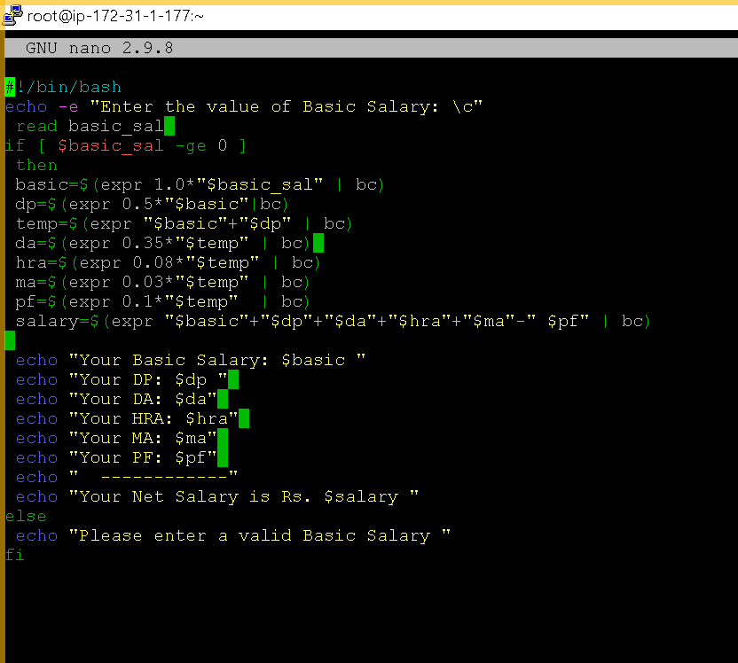

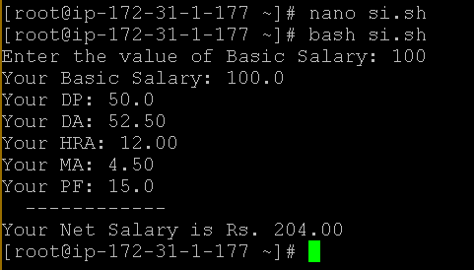

1. Write a shell script to calculate the average of a set of N number.

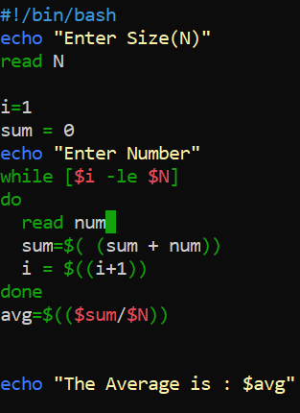

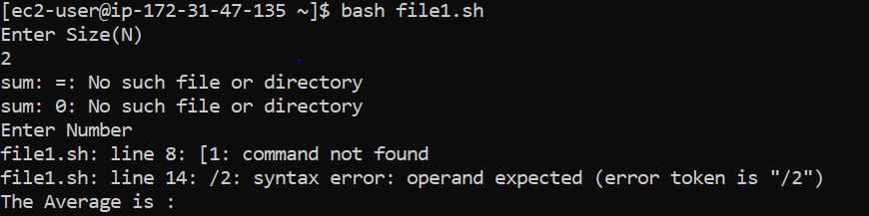

1. Write a Unix shell script to find the sum of number to given number.

e.g. if entered number is 5 then 1+2+3+4+5

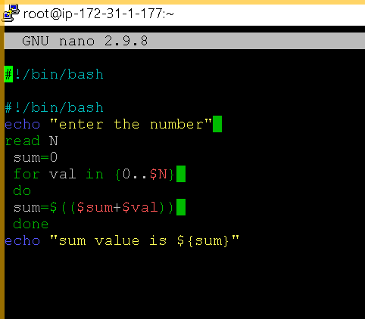

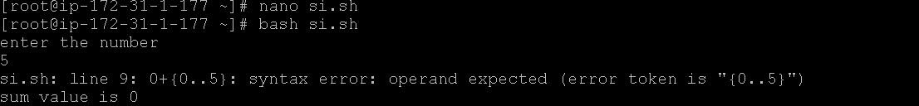

1. Write a shell script to perform like calculator. It should ask for the number and operand from the user.

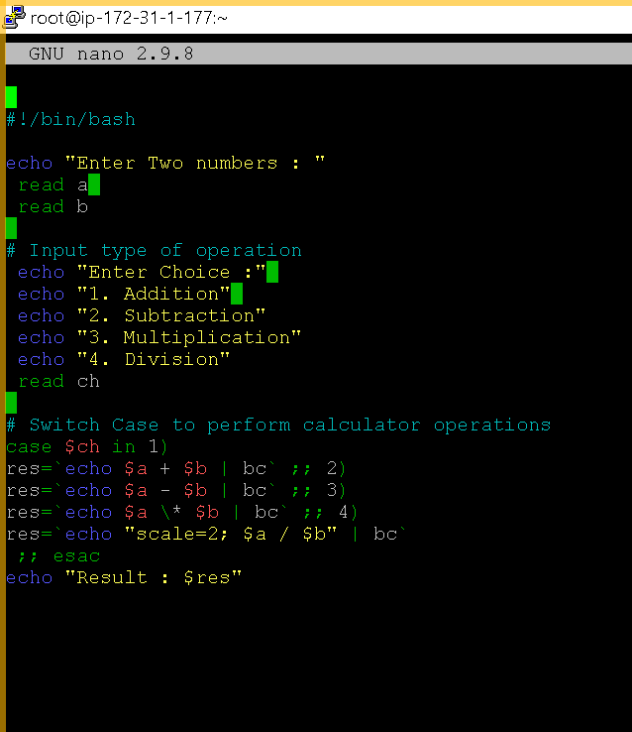

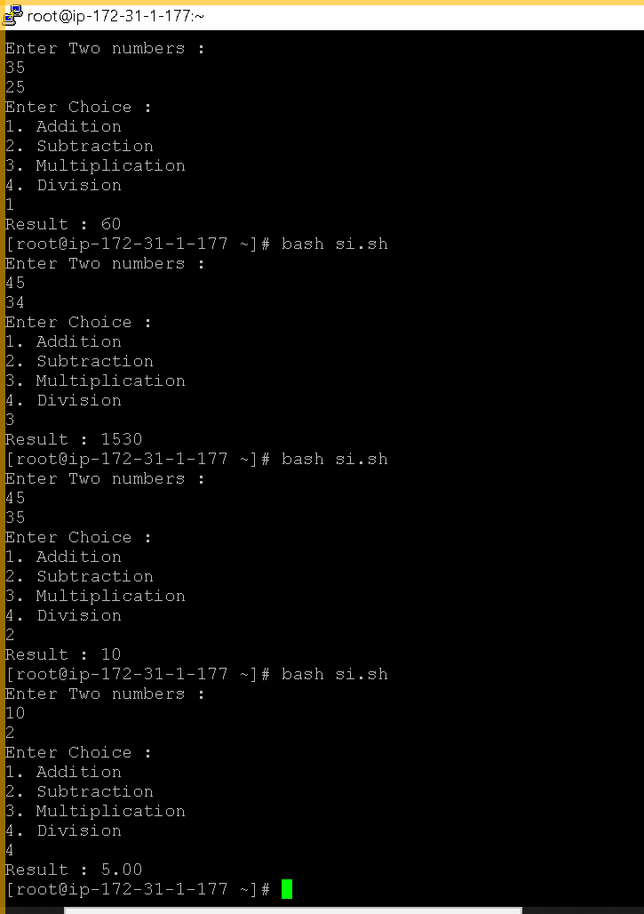

# 

# Assignment-2

1. Write a shell script to calculate the area of rectangle. It should take the value from the command line.

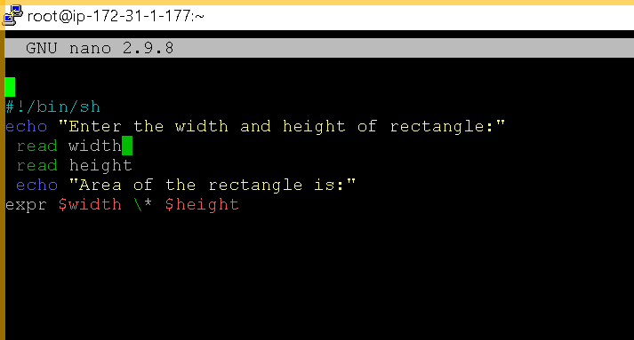

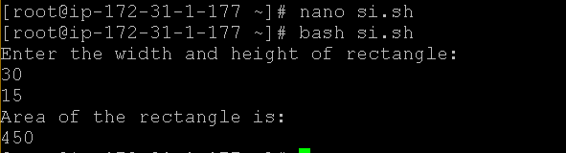

1. Write a shell script to take two numbers from command line and show result of dividing small number with bigger number. Also note that it should not accept zero or negative number. If user enter zero or negative number then it should prompt to input correct number after displaying proper message.

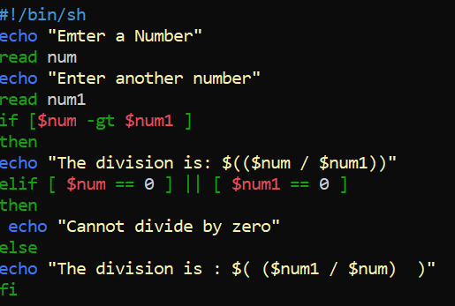

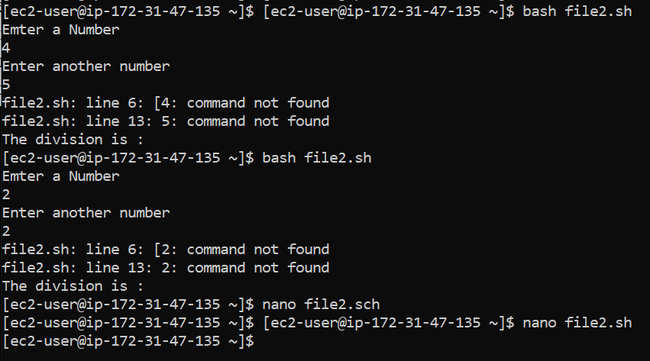

1. Write a Unix Shell Script which prints the following
   * 1. Current home directory.
     2. Current user name.
     3. The message "Today is :" with current date in MM/dd/yy format
     4. The message "No of users logged in :" with total no of current logged in users

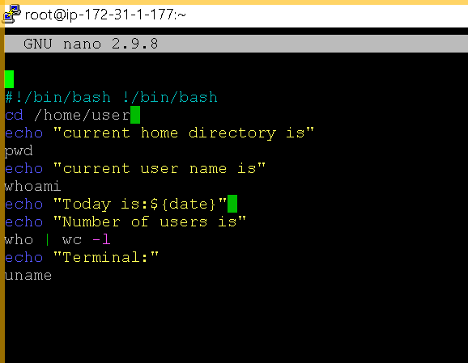

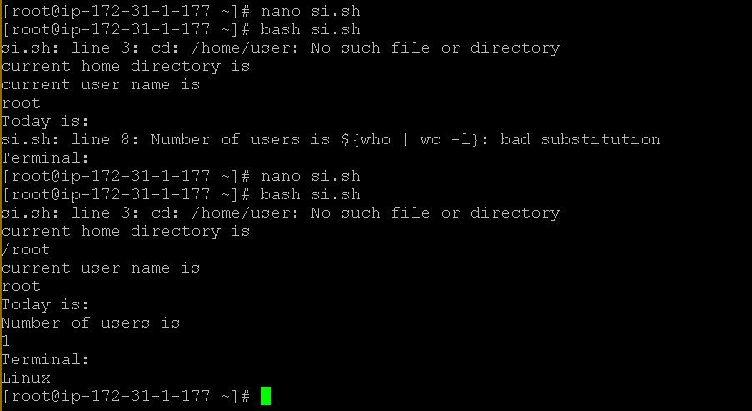

* + 1. The message "Terminal :” With you own terminal number 4. Write a shell script to create a command line calculator.

e.g. input : mycal 5 + 5 Result : 10 , input : mycal 5 / 5 result : 1

5. Write a shell script that that takes as command line input a number N and a

Word. it then prints the word n times., one word per line

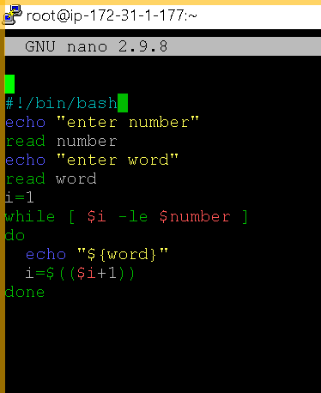

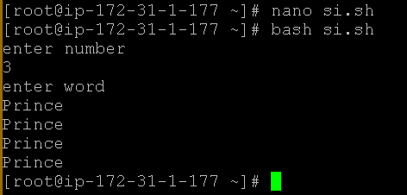

**Assignment-3**

1.Write a shell script to rename file having extension sh to exe.

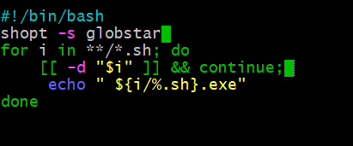

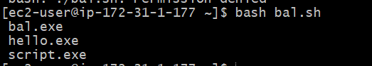

4. Write a shell script to display Date in different format along with Time.

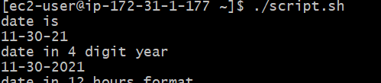

3. Write a shell script to examine all the number from 1 to 999 and display all those number whose sum of cube of the digit is equal to the number. e.g. 371 = 3*3*3+7*7*7+1*1*1

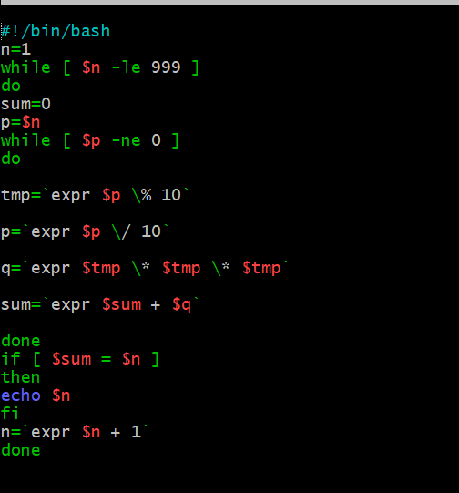

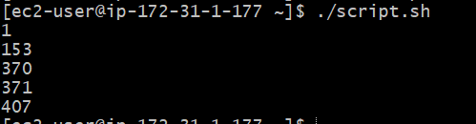

5. Write a shell script to accept fine number and display max and min value. If any two or three or four values are same then display proper message.

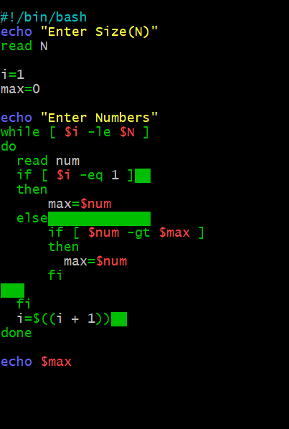

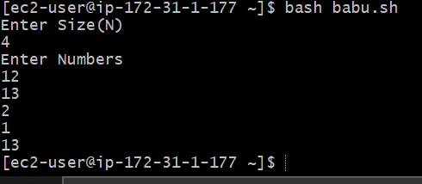

Assignment-6

Write a script to find out String is palindrome or not.

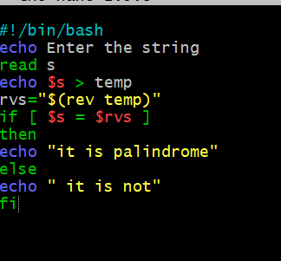

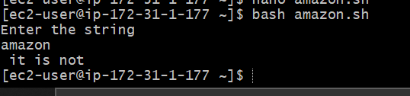

Write a Shell script to calculate the gross salary of Rajesh whose Basic is input through keyboard. His DA is 34% of basic salary and HRA is 24% of Basic. PF is 11% of the basic.

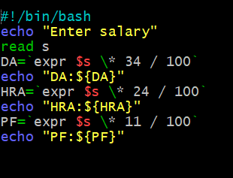

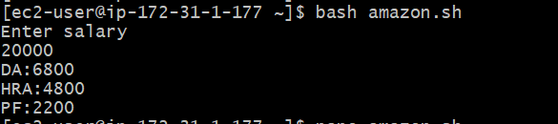

3. Write a shell script for accepting the following information and storing it in a file.

CD No., Movie Name, Language, Price and Date of release

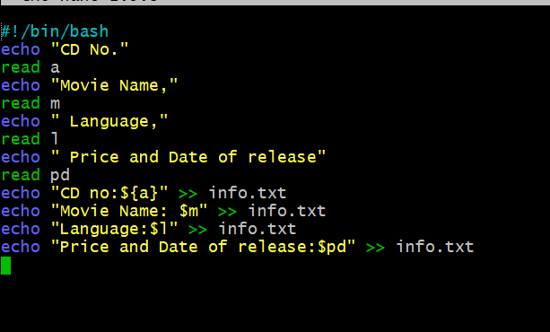

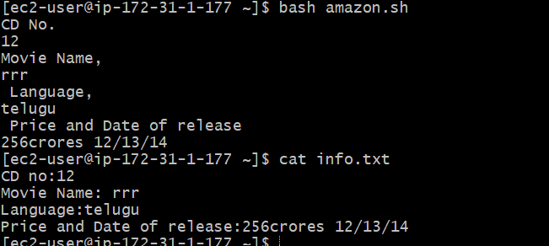

4.Write a scripts which copies the content of file1 to file2 without using cp command It should check If file has a read permissions if not it should print an error message. If file2 exits then it should ask the user whether he wants to overwrite it.

5. Write a shell scripts that delete all files in current directory with 0 byte.

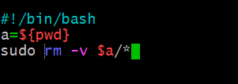

By doing this all files are deleted

1. Write a shell script to accept fine number and display max and min value. If any two or three or four values are same then display proper message.

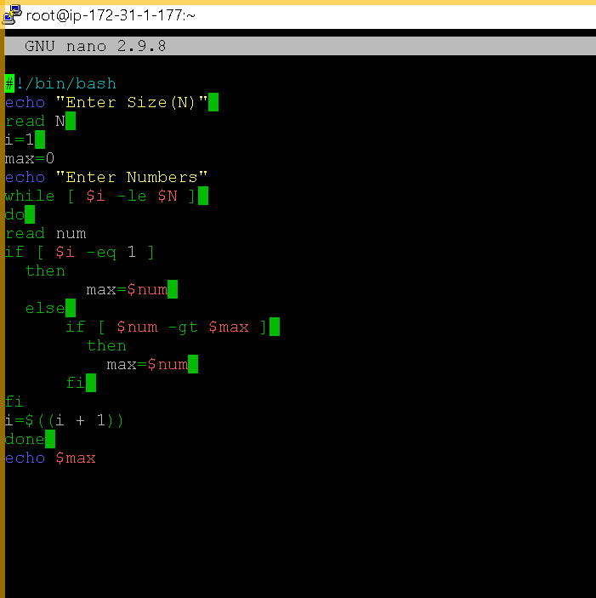

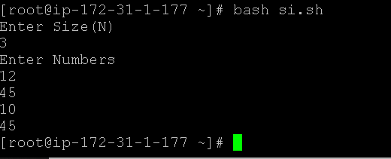

# Assignment-7

1. Write a shell script to display a directory listing as follows. Your home directory is <home directory name>

|  |  |  |  |
| --- | --- | --- | --- |
| File name | date | time | permission |
| ------------- | ------ | ----- | --------------- |
| Filename1 | date | time | permission |
| Filename2 | date | time | permission |
| Filename3  ……….. | date | time | permission |

………..

Total no. of files : <total number>

Total no of normal file : <number>

Total no of directory : <number>

1. Write a shell to accept the details for movie LIBRARY. movie No.

Name of the movie

director actor

actress

Year of release

category

Validations

* 1. Movie no. should not exist in the file.
  2. 2,3 and 4th entry cannot be blank
  3. year of release cannot be >= 2008
  4. Year or release should be less than 1850
  5. Category can be comedy, action, thriller, Suspense The user should be able to repeatedly enter the data until it is valid. He should also be able to enter multiple records

1. Write a shell procedure to delete the specified record from the library file. It should accept a movie number, check whether it is exists. If so, display the current details, ask for confirmation and then delete it from the file.
2. Write a shell script to menu driven program that is update and delete student records.
3. Write a shell script to accept 2 matrices and add them & display.

**Assignment-8**

1. Write a shell script to list all the files of the current directory having read and write permission to the user.

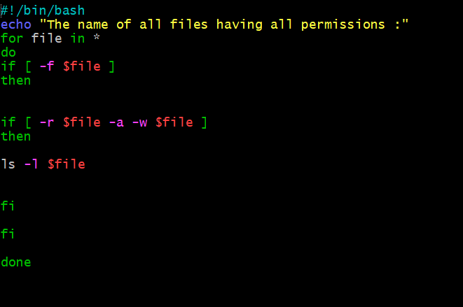

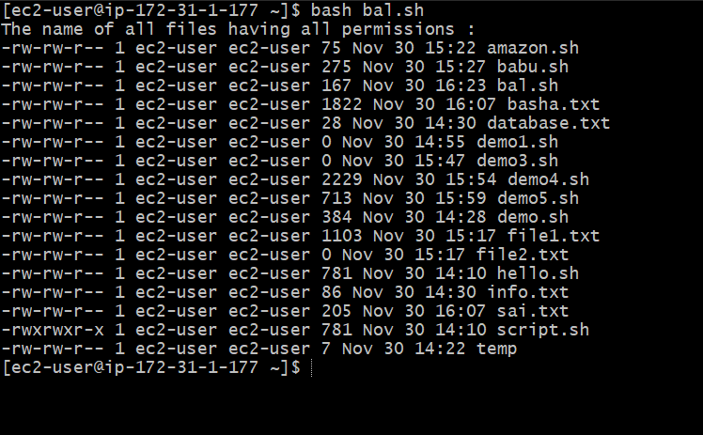

2. Write a shell script to checks if name given is file or directory and if it is file then it should display content and if it is a directory then it should display the list.

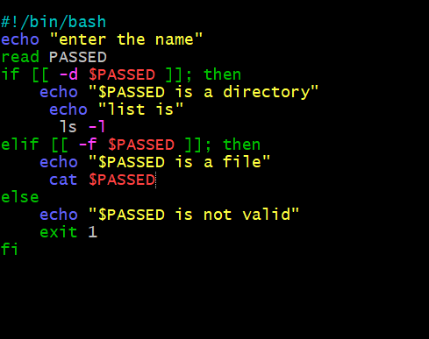

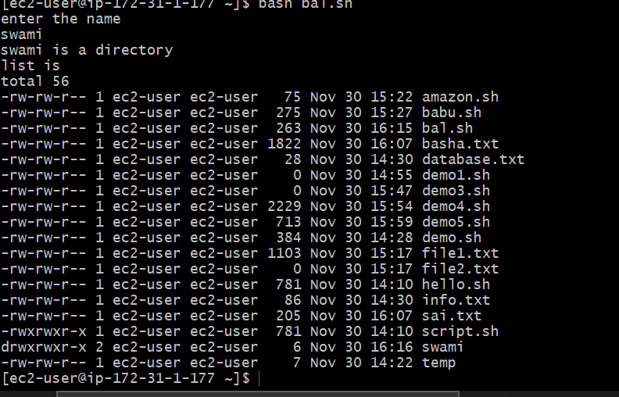

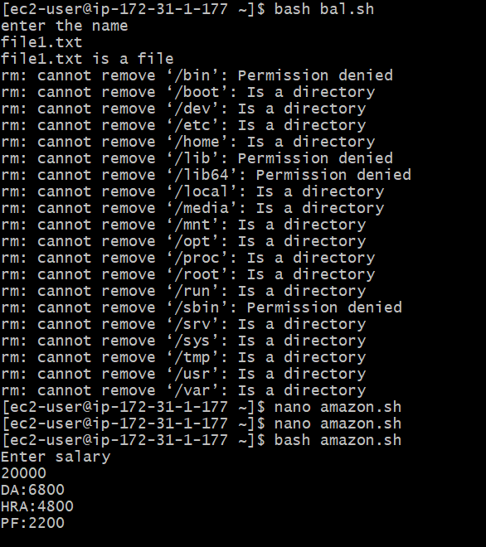

3. Write a shell script to accept two filenames and check if both exits. If second file exists then append the content of first file to second file.

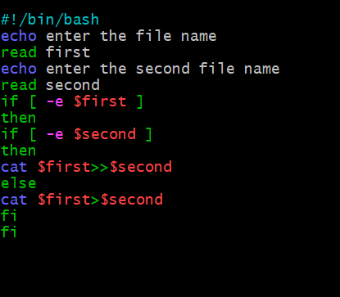

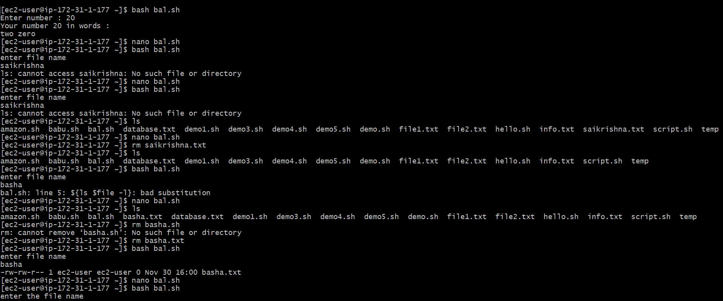

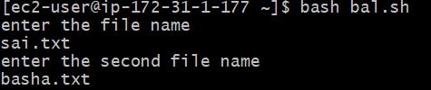



4. Write a shell script to input a number & display in words.

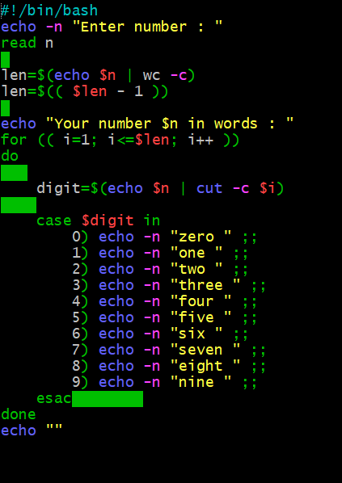

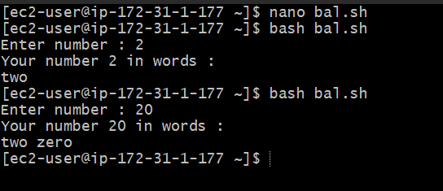

5. Write a shell script to input a file name and display rights.

